Database Tables Snapshots :

Schema or Logical DB NameUsed : **DEMODB**

Table Names are :

1. **demodb.gradedetails**

**2. demodb.orderdetail**

**3. demodb.grademix**

=> **GradeDetails table :** select query output and count of records as given in Grade_Details.txt file  
  
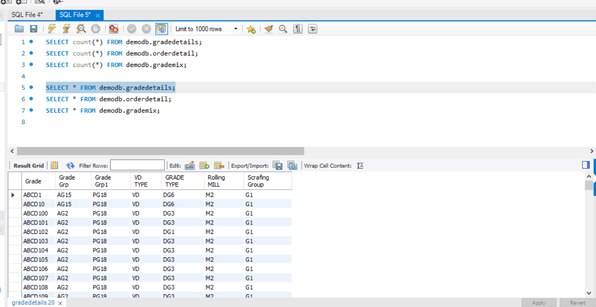

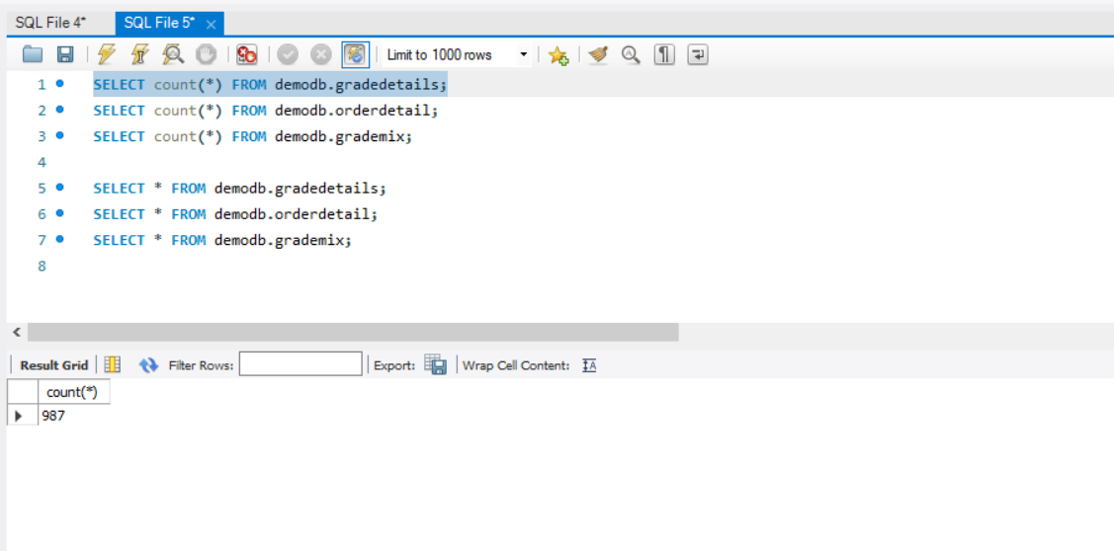

=> **OrderDetail table** : select query output and count of records as given in Order_Details.txt file

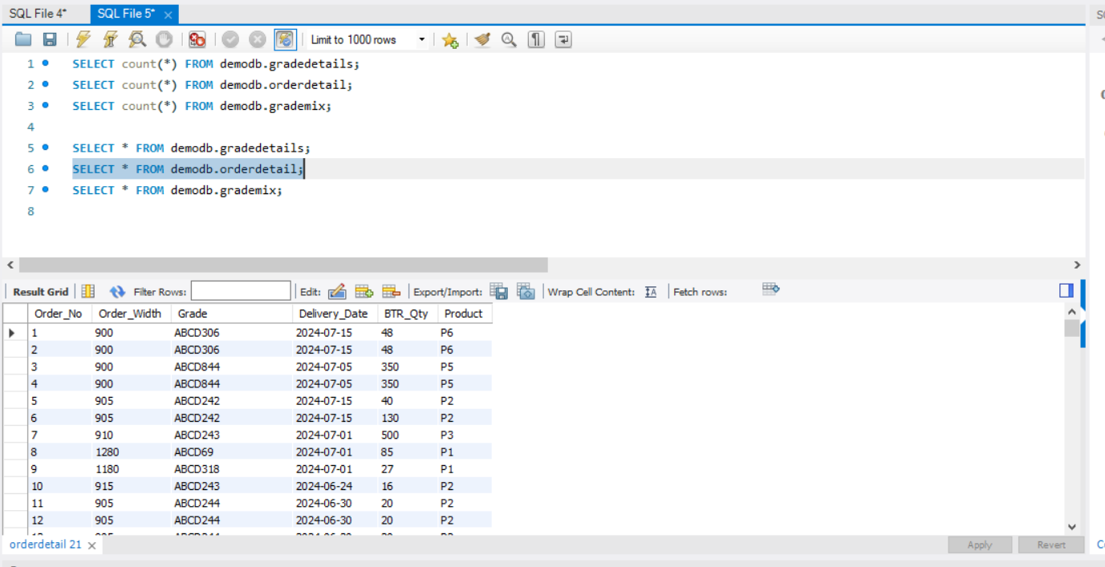

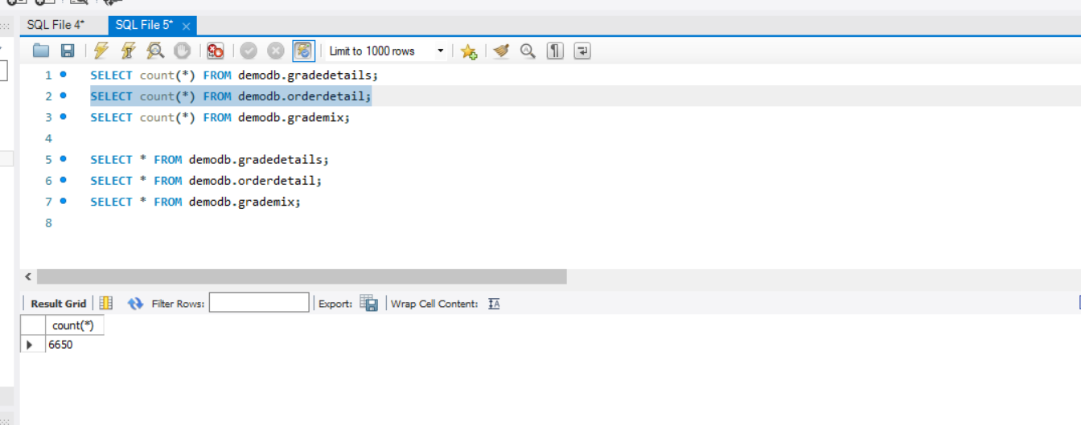

=> **GradeMix table** : select query output and count of records as given in Grade_Mix.txt file

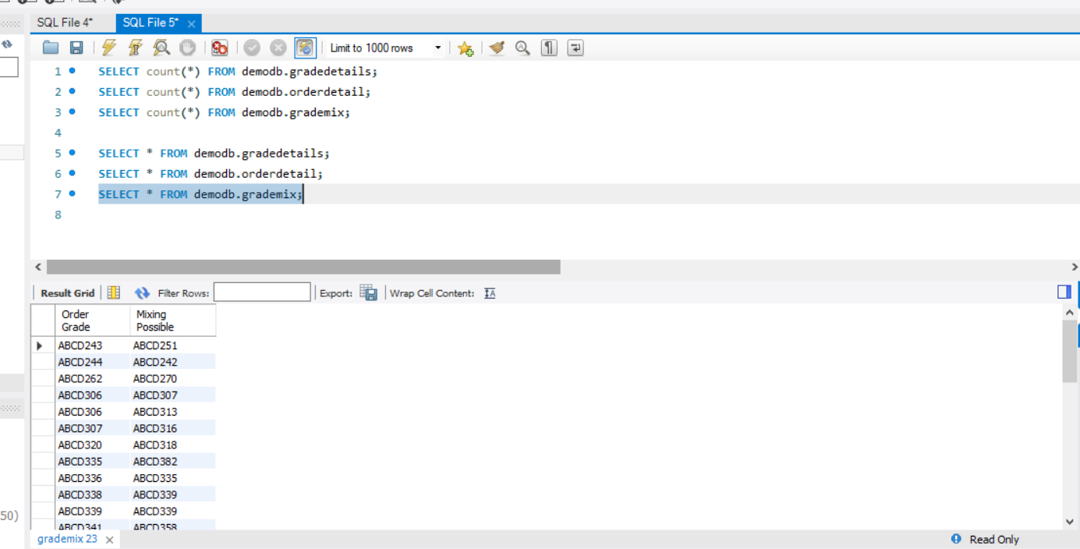

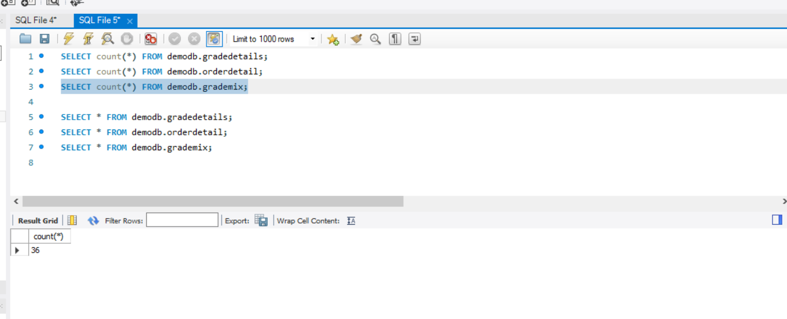

=> Output of query created to fetch records to Generate Level-1 Group and assign to records based on compatible grade or same grade.

